Philly Office Tower Rises With $187M in Construction Financing

The financing comprises a senior loan, mezzanine debt and a preferred equity component.

BY CATHY CUNNINGHAM AUGUST 11, 2020 11:43 AM
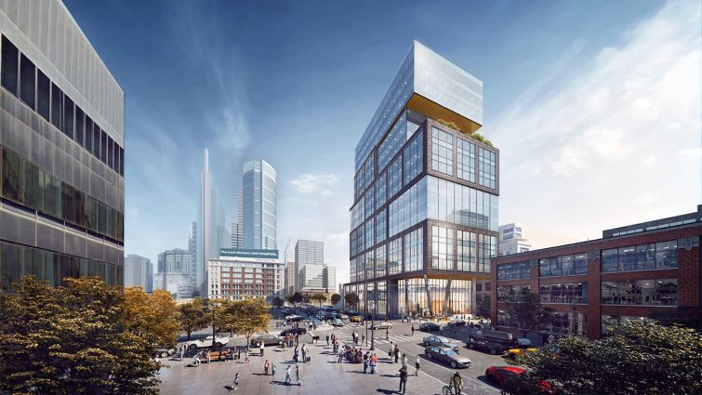

32
Parkway Corporation has landed $187 million in financing for the ground-up construction of 2222 Market Street in Philadelphia, Commercial Observer has learned.
The financing of the Class-A property comprised a senior loan, mezzanine debt and preferred equity. Sources told CO that the senior loan was provided by a syndicate of lenders that was led by Citizens Bank and included Santander Bank, while ACORE Capital provided the mezzanine component and the pref equity.
Deal parties confirmed ACORE’s role but declined to comment on the senior syndicate. Officials at Citizens declined to comment and Santander representatives could not immediately be reached.
Meridian Capital Group’s Morris Betesh, Ronnie Levine, Phil Galligan, Thomas Wayda and Omar Ferreira negotiated the financing.
Located in Philly’s Center City neighborhood, the 19-story, built-to-suit trophy office comprises 305,000 square feet and is pre-leased to law firm Morgan, Lewis and Bockius. When completed, its amenities will include a 3,500-square-foot fitness center, a rooftop terrace and a 50-space below-grade parking garage.
“This is going to be a tremendous project, and an important addition to a dynamic and vibrant Center City Philadelphia. We are thrilled to be a part of the deal, and more importantly, a part of the team, from Parkway Corporation and Morgan Lewis to Meridian Capital and our lending partners,” Tony Fineman, Head of Eastern Region Originations at ACORE, told CO. “This transaction is extra special to me, having grown up in Philadelphia. I attended college a few blocks away. We look forward to watching the progress of the development and seeing its inevitable success.“
Sitting close to City Hall and also the new Comcast headquarters, the Gensler-designed office property will be the first non-Comcast commercial office building in the city’s central business district in over 30 years.
“It was an honor to be a part of such a landmark transaction in the city of Philadelphia. The financing featured a multiple bank syndicate, arranged by Meridian, as well as mezzanine debt and a preferred equity component,” Betesh said. “Needless to say, we had to thread a needle throughout the COVID crisis, however our lenders and capital partners stood by us the whole way, which is a testament to the quality of this project. With this closing, Parkway continues to cement itself as one of the preeminent developers continuing to transform the city of Philadelphia.”

