Multifamily Mezzanine Lenders Are Changing Course
Lenders wait in the wings as sponsors revamp strategies.
MultiHousing News
OCT 2, 2020
Sibley Fleming

While most mezzanine lenders have hit the pause button for much of 2020, this category of debt is expected to increasingly fill a growing need in the capital stack as multifamily borrowers navigate the COVID-induced downturn to build new product and recapitalize existing assets.

With interest rates at near-historic lows, and Fannie Mae and Freddie Mac aggressively injecting liquidity into the market, multifamily borrowers with stabilized properties should have relatively little difficult securing capital, industry insiders say.
Hollywood Backlot Homes, a 10-acre manufactured home community aimed at providing affordable housing in a constrained, high-demand Los Angeles submarket.
“Borrowers on stabilized properties … getting lower LTV loans potentially will create some demand for some mezzanine loans to provide cheaper financing than equity,” noted Andrew Foster, Mortgage Bankers Association associate vice president and director of commercial/multifamily policy. Current dynamics will create a “huge opportunity” for mezzanine loans in the months and years to come, he added.
And there’s no shortage of mezzanine lenders; Commercial Mortgage Alert’s 2019 list includes more than 150 lenders, accounting for more than $40 billion in loan originations. Borrowers seeking mezz debt on properties that are not stabilized should still be able to find financing, if at higher spreads.
Scott Modelski

Few borrowers in the multifamily space are seeking mezzanine debt in the current market, reports Scott Modelski, managing director for Black Bear Capital Partners. Instead, more are taking advantage of the low rates offered by Fannie and Freddie.
“As we go through the end of this year and the beginning of next, once we start seeing some distressed deals, and we’re going to see the resetting of basis on some of these deals, then I think you’re going to see the mezzanine lender step into the void because they’re going to just look at the price per square foot and get a lot more comfortable than where we are now,” predicted Scott Modelski, managing director for Black Bear. Of the firm’s $1.5 billion deal pipeline, no new multifamily mezzanine loans have been originated since the beginning of the pandemic.
Andrew Foster

Other lenders are already seeing a modest increase in mezz debt activity. Before the pandemic, PGIM Real Estate was generating relatively low volume on account of what it considered poor risk-adjusted returns, reported Steve Bailey, managing director & head of debt strategies. “While there are few data points of closed transactions to look to over the past two quarters, our pipeline of what we consider to be viable mezzanine transactions has increased considerably versus pre-pandemic levels,” he said.

To put that in perspective, however, that uptick is relative; Bailey doesn’t expect PGIM’s mezzanine volume to increase significantly until 2021. Strong sponsors and sound market are the “first screens” for PGIM. Maximum LTVs are 80 to 85 percent maximum, and loan sizes range from $20 million to $200 million. “Beyond those factors, we are pretty flexible and have the ability to structure both debt-like mezzanine loans as well as equity replacement mezzanine loans,” he said.
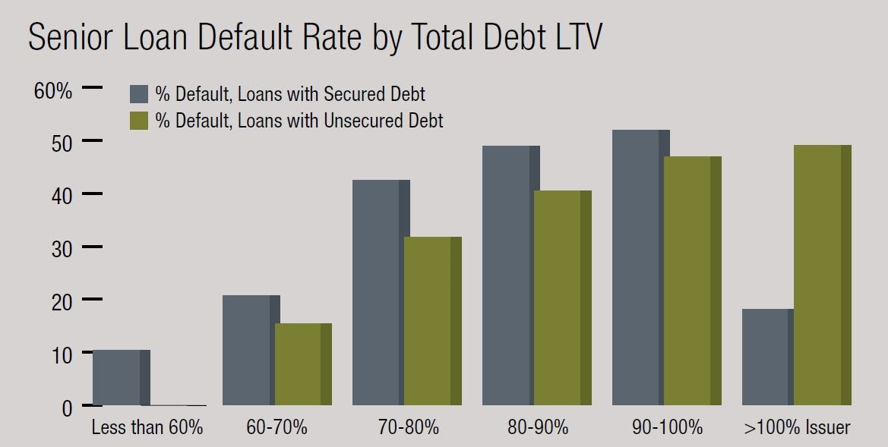Sources: Fitch Ratings, Trepp

Acore Capital originated few new loans during the spring and summer and like most lenders, used the downtime to recalibrate its strategy and focus on its existing portfolio, reports Warren de Haan, managing partner & head of originations. One of the nation’s top three bridge lenders, Acore originated $8 billion in new loans last year, 25 percent of it for multifamily properties. That compares to $4 billion to $5 billion de Haan anticipates in total originations over the next 12 to 18 months, including $1 billion to $1.5 billion for multifamily. Acore’s lending team continues to pursue multifamily construction loans for select markets and sponsors, as well as loans on properties completing construction and in need of a bridge to an agency takedown, he says.

Acore’s leverage ranges from a 65 percent loan-to-cost at the low end to 85 percent on the high end for construction loans. Deals vary from ground-up Class A multifamily projects to rehabilitation of Class B and Class C communities where the borrower is buying at a discount and investing $8,000 to $30,000 per door to upgrade and reposition the properties.
Warren de Haan

Despite low level of origination this year, de Haan predicts the recessionary environment will create a need for more bridge capital across sectors. “The big variable for multifamily is stimulus versus less stimulus and any legislation that does not allow owners of multifamily to evict their tenants,” he explains.

A Fitch Ratings study released in April underscored the positive impact of subordinate debt on the CMBS capital stack. The agency evaluated 1,001 CMBS conduit loans issued between 2003 and 2008 with subordinate debt in place. Fitch concluded that for senior loans with mid-range leverage and unsecured subordinate debt such as mezzanine debt and preferred equity, the default rate is 25 percent lower than for loans with secured subordinate debt, specifically B-notes and C-notes.
For loans with moderate leverage—60 percent to 70 percent loan to value—the default rate for senior loans with unsecured subordinate debt was 26.2 percent lower than for loans with secured subordinate debt. Loans with mid-range leverage profiles of 70 percent to 80 percent, the default rate was 25.3 percent lower for loans with unsecured subordinate debt; loans with LTVs in the 80 percent to 90 percent range, the difference was 17.2 percent. For the majority of loans in the sample (77.1 percent), total debt LTVs ranged between 60 percent and 90 percent.

MBA’s Foster considers the study telling because it speaks to two arguments about attaching a mezzanine loan to a property: “The first goes something like: It’s really good to have another potential operator at the table, because often the mezzanine lender may have experience owning and operating properties or relationships with property managers,” he says.
The flip side is that a mezzanine loan adds complexity and more room for lenders to disagree when things get challenging.

GOOD CREDIT, ACTIVE MANAGEMENT
Toby Cobb

Toby Cobb, co-founder and managing partner of 3650 REIT, which specializes in full capital-stack loans, says so far his company has only one multifamily loan that is past 60 days delinquent, which he attributes to good credit on the front end and active risk management on the back end. “I think we’re quite fortunate. We really just have one asset that’s in an environment where the tenants feel as though they are not compelled to pay,” he said.

That asset is in New York City where some mezz lenders have taken borrowers to court with the intent to recoup their losses through foreclosure. The step follows through on a provision that allows the mezzanine lender to convert debt to equity in the event of a default.

Like Acore, 3650 REIT is focused on multifamily construction debt. During the pandemic, the mortgage REIT has provided mezz financing only as a part of full capital stack multifamily construction loans. In June, 3650 REIT originated a $36 million bridge loan for the acquisition and redevelopment of Hollywood Backlot Homes, a 10-acre manufactured home community aimed at providing affordable housing in a constrained, high-demand Los Angeles submarket.
Thanh Bui

Multifamily remains a favored asset class, despite less transparent valuations and reduced transaction volume, noted Thanh Bui, managing director at Clarion Partners. “Clarion has adjusted underwriting to be in line with the more cautious environment, and lending criteria is appropriately more conservative, with additional credit structures, lower LTV and longer periods for borrowers to execute business plans,” she said.

Debt investments have been predominantly subordinate debt structures as mezzanine or preferred equity investment between 50 percent and 80 percent LTV with loan sizes from $10 million to $100 million-plus and interest rates risk-adjusted depending on the transaction and sponsor’s real estate strategy. Total gross IRR ranges between 7 percent for core assets to double digits for value-add and opportunistic investment, typically unlevered.

“Subordinate debt in some form has been a part of the capital structure for decades, and Clarion believes it will continue to be an important part of the capital structure in 2020 and beyond,” Bui says. “Borrowers will continue to seek capital for acquisitions, re-financings or re-capitalizations of assets beyond the proceeds level of traditional senior lenders.”

